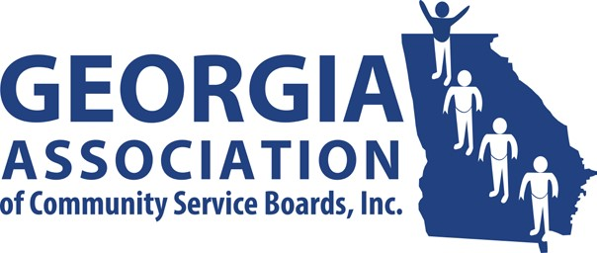**GACSB Board of Director Meeting**

**Wednesday November 13, 2024**

**10:00AM**

# Join Zoom Meeting

# <https://us06web.zoom.us/j/85925991279>

# 

# Meeting ID: 859 2599 1279

# Passcode: 287840

# Agenda

1. Welcome/Preamble Alecea Quintyne

1. Approve 10/13/2024 Agenda Alecea Quintyne

1. Approve Minutes Alecea Quintyne

* *10/09/2024- Regularly Scheduled Board Meeting*
* *09/26/2024- Special Board Meeting*

1. Financial Report Cindy Levi

1. Committee Reports
   * *Administrative Operations* Pam Cartwright
   * *Clinical Operations* Jennifer Hibbard
   * *Data Analytics* Tammy Conlin
   * *Education & Individual Advocacy* Dana Glass
   * *Intellectual/Developmental Disabilities* Cindy Levi
   * *Public Image & Policy* Melanie Dallas
2. Executive Director’s Report Kristin Woodlock

1. Board Comment Alecea Quintyne

1. Public Comment Alecea Quintyne

1. Next Meeting Alecea Quintyne

✓ 12/11/2024

1. Adjournment Alecea Quintyne