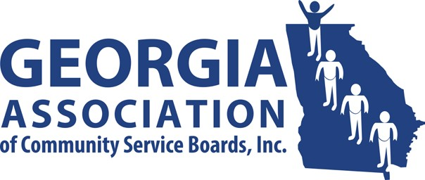
GACSB Board of Director Meeting
Wednesday December 10th, 2o25
10:00AM

Join Zoom Meeting

https://ccsi.zoom.us/j/99489134562

Meeting ID: 994 8913 4562

Passcode: 494890

Agenda

- Welcome/Preamble David Kidd

- Approve 12/10/2025 Agenda David Kidd

- Approve Minutes David Kidd
- 11/12/2025- Regularly Scheduled Board Meeting

- Financial Report Kathy Johnson
- True North Ellen and Bernard Reynolds

- Committee Reports
  - Administrative Operations Pam Cartwright
  - Clinical Operations Kenyatta Walker
  - Data Analytics Tammy Conlin
  - Education & Individual Advocacy Dana Glass
  - Intellectual/Developmental Disabilities Cass Hatcher
  - Public Image & Policy Jennifer Hibbard

- Executive Director’s Report Vanessa Cameron

- Committee Chairs David Kidd

- Board Comment David Kidd

- Public Comment David Kidd

- Next Meeting David Kidd
✓ 1/14/2026 at 10:00

- Adjournment David Kidd

