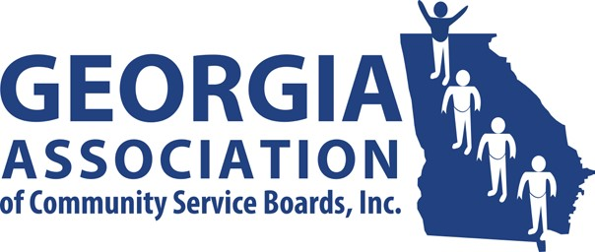**GACSB Board of Director Meeting**

**Wednesday October 8th, 2o25**

**10:00AM**

# Join Zoom Meeting

# https://ccsi.zoom.us/j/99489134562

# Meeting ID: 994 8913 4562

# Passcode: 494890

# Agenda

1. Welcome/Preamble David Kidd

1. Approve 10/08/2025 Agenda David Kidd

1. Approve Minutes David Kidd

* *08/05/2025- Regularly Scheduled Board Meeting*

1. Financial Report Kathy Johnson
2. Committee Reports
   * *Administrative Operations* Pam Cartwright
   * *Clinical Operations* Kenyatta Walker
   * *Data Analytics* Tammy Conlin
   * *Education & Individual Advocacy* Dana Glass
   * *Intellectual/Developmental Disabilities* Cass Hatcher
   * *Public Image & Policy* Jennifer Hibbard
3. Executive Director’s Report Vanessa Cameron

* Select Systems

1. Committee Chairs David Kidd
2. Board Comment David Kidd

1. Public Comment David Kidd

1. Next Meeting David Kidd

✓ 11/12/2025 at 10:00

1. Adjournment David Kidd