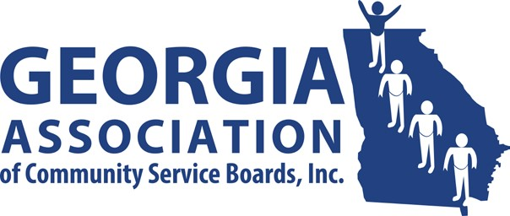
GACSB Board of Director Meeting
Wednesday February 11th, 2o26
10:00AM

Join Zoom Meeting

https://ccsi.zoom.us/j/99489134562

Meeting ID: 994 8913 4562

Passcode: 494890

Agenda

- Welcome/Preamble David Kidd

- Approve 2/11/2026 Agenda David Kidd

- Approve Minutes David Kidd
- 1/14/2026- Regularly Scheduled Board Meeting

- Financial Report Kathy Johnson
- FY 2025 Audited Financial Statements and 990
- New Banking Resolution

- Governmental Affairs True North

- Committee Reports
  - Administrative Operations Pam Cartwright
  - Clinical Operations Kenyatta Walker
  - Data Analytics Glyn Thomas
  - Education & Individual Advocacy Dana Glass
  - Intellectual/Developmental Disabilities Cass Hatcher
  - Public Image & Policy Jennifer Hibbard
  - Ad Hoc Committee Vanessa Cameron

- Executive Director’s Report Vanessa Cameron

- Committee Chairs David Kidd

- Board Comment David Kidd

- Public Comment David Kidd

- Next Meeting David Kidd
✓ 3/11/2026 at 10:00

- Adjournment David Kidd

