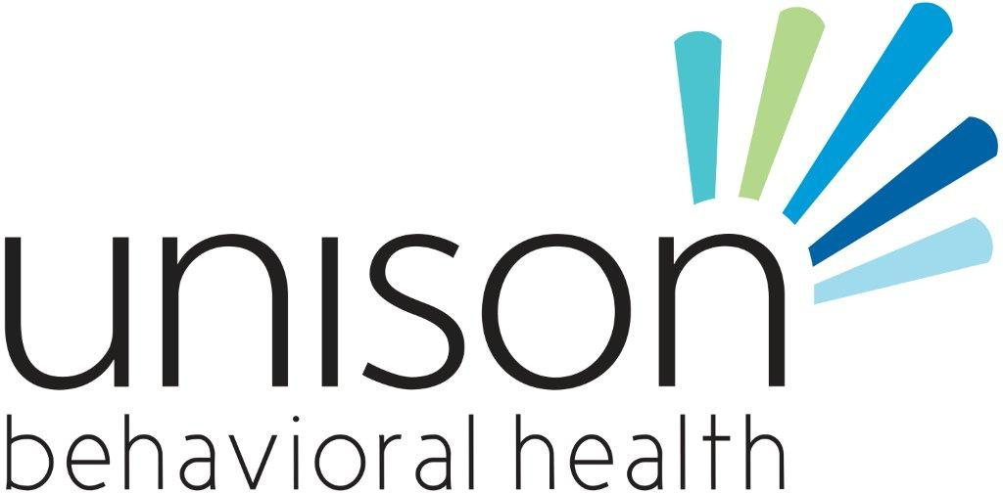

**Behavioral Health Provider II, III or IV**

**Location: Youth Mental Health Resiliency Clubhouse**  **Closing date:**  Open until Filled

**Annual Salary:** Commensurate with education and credentials

**Job Description:** Provides community support interventions to clubhouse youth to include but is not limited to: home/school/community visits to provide skill building services to achieve therapeutic goals related to behavioral health diagnosis, follow-ups on absenteeism, telephone calls providing appointment reminders and barrier checks, etc. Services may be provided to members in group or individual settings. Provides on- going support for youth and families in after-care services. Responsible for obtaining authorization, coordinating and driving transportation routes before and after clubhouse sessions.

The Mental Health Resiliency Clubhouse is an after school program designed to provide a comprehensive and unique set of services for children and families coping with the isolation, stigma and other challenges associated with behavioral health needs. The program utilizes creative approaches and experiences to promote resiliency through improving behavioral health functioning, school functioning, decreasing involvement with Department of Juvenile Justice and increasing youth, family and community engagement.

**Job Responsibilities:** Monday-Friday 10:00 am -7:00 pm; Will assist with activities with youth on weekends (once a month).

**Competencies:** 1. Knowledge of community resources and connections. 2. Knowledge of recovery process and symptom management 3. Good organizational, interpersonal and communication skills are a must. 4. Knowledge of basic computer skills.

**Required Minimum Qualifications:**  HS Diploma with 1-5yrs MH experience**: Preferred** Bachelors in Social Service related field with at least one year of experience in MH exp.

ADDITIONAL NOTES: Due to the volume of applications received, we are unable to provide information on application status by phone or e-mail. All qualified applicants will be considered, but may not necessarily receive an interview. Selected applicants will be contacted by the hiring agency for next steps in the selection process. Applicants who are not selected will not receive notification.  This position is subject to close at any time once a satisfactory applicant pool has been identified. Unison BH is a tobacco-free campus.

We create health and wellness in our communities by providing quality mental health, substance abuse and developmental disability services.

**To submit an application and resume go to our website:**

[**www.unisonbehavioralhealth.com**](http://www.unisonbehavioralhealth.com)

**Click on Join our Team**

**Any questions? Email Camille Conley @**

[**cconley@unisonbh.com**](mailto:cconley@unisonbh.com)

**Submit resume and cover letter by mail, email or fax to:**

**Kim Smith, HR Department**

**P.O. Box 1397**

**Waycross, GA 31502**

**ksmith@satillacs.org**

**FAX: 912-449-7058**

[**ksmith@satillacs.org**](mailto:ksmith@satillacs.org)

***Unison Behavioral Health is committed to providing accessible, quality behavioral health and developmental disability services to individuals and families throughout southeast Georgia. We offer a full continuum of CARF accredited programs serving over 5900 individuals each year.***

***Unison Behavioral Health is an equal opportunity employer. A background check will be completed upon hire, which may consist of any of the following: FBI criminal history, employment history, educational records, and driving records.***