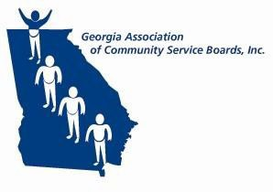

**GACSB**

**Administrative Operations Committee Thursday, October 9, 2025**

**10:00 a.m.**

**Join Zoom Meeting**

<https://bhsga.zoom.us/j/81655903895?pwd=4Iisdc1n6nMraQc0AfRbEKSNgRrEiP.1>

Meeting ID: 816 5590 3895

Passcode: 747877

1. **Welcome/Call to Order** Pam Cartwright
2. **Approve 10/9/2025 Agenda** Pam Cartwright
3. **Approve 9/11/2025 Minutes** Pam Cartwright
4. **Focus Group Reports** Focus Group Leads
   * *HR/Compliance -Laura Fullard*
   * *IT-Fabio van der Merwe*
   * *CFO-Lee Pavlik*
   * *Revenue Cycle- Angela Holt*
5. **Strategic Plan Initiatives Update** GACSB Executive Office
   * *Strategic Priorities 1-4*
6. **State-wide Policy Initiatives** GACSB Executive Office
   * *CCBHC Updates*
   * *DBHDD Updates*
   * *GACSB Updates*
     + *2025 GACSB Educational Exchange*
7. **Other** Pam Cartwright

* *Disaster Preparedness/Continuity of Operations Plan*
* *Renter’s Insurance Discussion*

1. **Next Meeting** Pam Cartwright
   * *Thursday, November 13, 2025*
   * *10:00am*
   * *Zoom*
2. **Adjournment** Pam Cartwright